OTA Design

OTA app

Overview
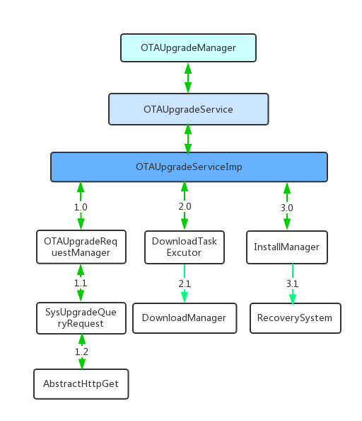

Code Organization
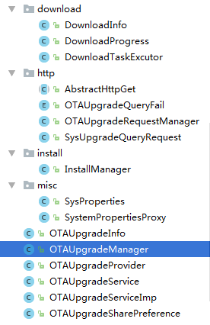

Class Diagram
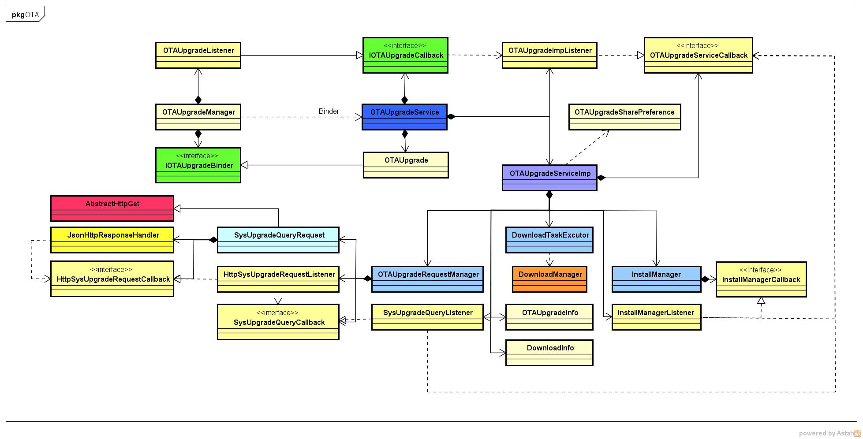

Interface list

Call Sequence

Use Case

// module use cases descriptions

